End Semester Project Report on
AMPLITUDE MODULATOR AND DEMODULATOR

Submitted for the partial fulfillment of the subject
Analog Circuits Workshop
(EET1707)

SHANI KUMAR (25E111A81)

B. Tech. 1st Semester (Section– 25E1U2)



DEPT. OF ELECTRONICS & COMMUNICATION ENGINEERING
Institute of Technical Education and Research

SIKSHA ‘O’ ANUSANDHAN
DEEMED TO BE UNIVERSITY

Bhubaneswar, Odisha, India.
(2025)

Abstract

An amplitude modulator and demodulator system is a fundamental component in analog Communication, enabling the transmission and recovery of information via variations in signal amplitude. The modulator operates by superimposing a low-frequency message signal onto a high-frequency carrier wave, producing an amplitude-modulated (AM) waveform. This process is typically achieved using a transistor modulator circuit or a balance demodulator IC, where the carrier and message signals interact to generate sidebands that carry the encoded information.

On the receiving end, the demodulator extracts the original message signal from the modulated carrier. This is commonly implemented using envelope detectors or synchronous demodulation techniques. Envelope detection relies on diode-capacitor networks to trace the signal’s amplitude envelope, while synchronous demodulation uses a locally generated carrier to precisely recover the message signal, offering improved fidelity in noisy environments. Amplitude modulation systems are widely used in radio broadcasting, telemetry, and legacy communication systems due to their simplicity and cost-effectiveness. Despite the rise of digital modulation schemes, AM remains relevant in applications where bandwidth efficiency and ease of implementation are prioritized. The combined modulator-demodulator setup demonstrates key principles of signal processing and serves as foundational experiment in electronics and communication engineering education.

Keywords: Analog Communication, Carrier Wave, Transistor Modulator, Envelope Detectors, Synchronous Demodulation, Amplitude modulation

Graphical Abstract

An amplitude modulator and demodulator system is essential in analog communication, enabling the transmission and recovery of signals through variations in amplitude. The Modulator combines a low-frequency message signal with a high-frequency carrier using a Transistor modulator circuit, producing an amplitude-modulated (AM) waveform. At the Receiving end, the demodulator—typically an envelope detector or synchronous Demodulator—extracts the original message from the AM signal. These systems are widely used in radio broadcasting and telemetry due to their simplicity, cost-effectiveness and Foundational role in signal processing

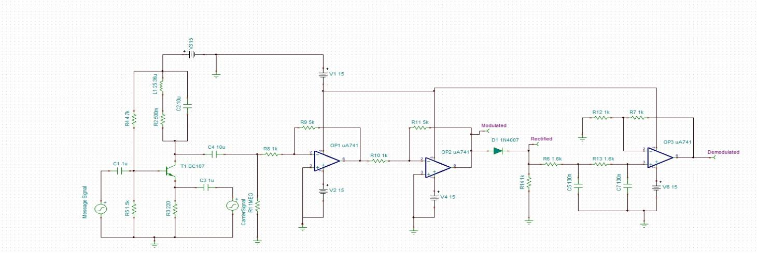

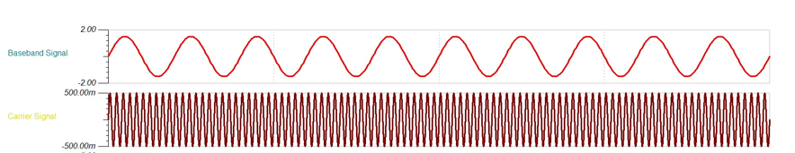
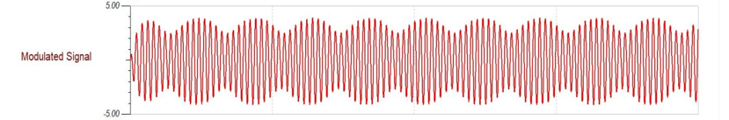

Contents

Abstract i
Contents iii
Chapter 01: Introduction 1
1.1. Introduction 1
1.2. Background 1
1.3. Project Objectives 2
1.4. Scope 2
1.5. Project Management 3
1.6. Overview and Benefits 4
1.7. Organization of the Report 5
Chapter 02: Theoretical Aspects 6
2.1 Background Theory and Modeling. 6
2.3 Project Layout 8
2.3.1 Brief Description 9
2.3.2 Block Diagram of the Proposed System 10
Chapter 03: Hardware and Software Requirements 13
3.1 TINA Design Software 13
3.1.1 Schematic Capture 14
3.1.2 Live 3D Breadboard Tool 14
3.1.3 PCB Design 14
3.1.4 Electrical Rules Check (ERC) 14
3.1.5 Schematic Symbol Editor 15
3.1.6 Library Manager 15
3.1.7 IBIS model Support 15
3.2 Results and Analysis of Results in TINA 15
3.2.1 DC analysis 15
3.2.2 Transient analysis 15
3.2.3 Piecewise Linear (PWL) Solver 16
3.2.4 Auto convergence. 16
3.2.5 Transient Noise Analysis. 16
3.2.6 Fourier analysis 16
3.2.7 Digital Simulation 17
3.2.8 HDL simulation 17
3.2.9 Microcontroller (MCU) simulation 17
3.2.10 Flowchart Editor and Debugger 17
3.2.11 AC analysis 18
3.2.12 Network analysis 18
3.2.13 Analytic SMPS and other device modeling 18
3.2.14 Linear AC Noise Analysis 18
3.2.15 Design Tool 18
3.2.16 Optimization 19
3.2.17 Post-processor 19
3.2.18 Presentation 19
3.3 Program Versions Available 19
3.4 List of New features in TINA 20
3.5 The Basic Screen Format 20
3.6 Operational Amplifier 23
3.6.1 Differential Amplifier 24
3.6.2 Equivalent Circuit of an Ideal Operational Amplifier 25
3.6.3 Op-amp Parameter and Idealized Characteristic 26
3.7 Open-loop Frequency Response Curve 27
3.8 An Operational Amplifiers Bandwidth 28
3.9 Ideal characteristics of an Op-Amp: 29
3.10 OPAMP Pin Configuration: 29
3.11 Bipolar Junction Transistors 30
3.11.1 NPN transistor working 31
$3.11.2$ Transistor Configurations 33
3.11.3 DC Load Line 35
3.12 Biasing in Transistors 38
3.12.1 Base-Current Bias (Fixed Bias) 39
3.12.2 Self-Bias 40
3.12.3 Voltage divider bias 41
4.2 Circuit and Test Results: 43
Mathematical Representation of spectrum: 46
4.3 Interpretation of Results 48
Chapter 05: Conclusion and Future Scope 51
5.1 Conclusion 51
5.2 Limitations 51
5.2.1 Limitations of AM Modulator (Transmitter): 51
5.2.2 Limitations of AM Demodulator (Receiver): 52
5.3 Further Enhancement and Future Scope 52
References 53
pAppendix 01 54
A01.1. Data Sheet I 54
A01.2. Data Sheet II 55

Chapter 01: Introduction

Introduction
Communication systems play a vital role in modern society by enabling the transmission of information over long distances with accuracy and reliability. Among various communication techniques, Amplitude Modulation (AM) is one of the earliest and most fundamental methods used in analog communication systems. In amplitude modulation, the amplitude of a high-frequency carrier signal is varied in direct proportion to a low-frequency message signal, while the carrier frequency remains constant. This technique made it possible to efficiently transmit audio signals such as speech and music over large distances using antennas, forming the backbone of early radio broadcasting systems.
Although modern communication systems predominantly use digital modulation techniques, AM continues to hold great educational and practical importance. It provides a clear understanding of essential communication concepts such as modulation, bandwidth, noise, and signal recovery. Historically, AM systems were implemented using vacuum tubes, but with technological advancement, Bipolar Junction Transistors (BJTs) replaced them due to their compact size, low power consumption, reliability, and ease of circuit implementation. Transistor-based AM modulators are widely used in laboratories and academic projects to demonstrate the practical realization of analog communication principles.
In this project, a complete Amplitude Modulator and Demodulator system is designed and implemented using discrete electronic components. A stable sinusoidal carrier signal is generated using an RF oscillator, which supplies the required high-frequency carrier for modulation. The carrier signal is applied to a BJT configured as a common-emitter amplifier, where the low-frequency message signal controls the instantaneous amplitude of the carrier, resulting in an amplitude-modulated waveform. Proper transistor biasing and careful selection of the modulation index ensure linear operation and minimize distortion. The modulated AM signal is taken from the collector output and passed through a tuned LC circuit to select the desired carrier frequency and reject unwanted frequency components.

Background
At the receiver section, the transmitted AM signal is demodulated using a diode-based envelope detector, which is the simplest and most commonly used AM detection technique. The diode rectifies the incoming AM signal, and an RC low-pass filter removes the high-frequency carrier components, allowing recovery of the original message signal. An operational amplifier stage may be used for buffering, amplification, and impedance matching to improve signal quality. This project provides hands-on experience in designing, analyzing, and testing AM modulation and demodulation circuits, thereby strengthening the understanding of analog communication fundamentals and their relevance in real-world communication systems.
In the early stages, AM modulation and detection were implemented using vacuum tube circuits; however, with technological advancement, these were largely replaced by Bipolar Junction Transistors (BJTs) because of their smaller size, higher reliability, lower power consumption, and ease of circuit implementation. In modern AM modulators, BJTs are commonly used in amplifier-based circuits driven by a stable RF oscillator, providing improved frequency stability and reduced signal distortion. At the receiver end, the modulated signal is demodulated using a simple diode-based envelope detector, followed by filtering and amplification stages to recover the original audio signal. Although modern communication systems predominantly use advanced digital modulation techniques, amplitude modulation remains an essential concept for understanding the fundamentals of communication engineering and the evolution of wireless communication systems.

Project Objectives
Modulation:
- In this process, a low-frequency message signal is combined with a high-frequency carrier signal.
- It allows the information signal to be transmitted efficiently over long distances.
- When the modulation index is properly adjusted, a clean and distortion-free AM signal is obtained.
Demodulation:
- In this process, the original message signal is separated from the received AM waveform.
- The demodulator reproduces the message signal with minimum distortion and reduced noise for accurate output.

Scope
- Practical Understanding of AM Systems
Provides hands-on experience in building and analyzing an amplitude modulator using a BJT and an envelope detector for demodulation.
- Signal Transmission and Recovery
Demonstrates how an audio signal can be successfully transmitted by modulating a carrier and accurately recovered at the receiver.
- Foundation for Advanced Communication Techniques
Serves as a basic platform for understanding more complex modulation schemes such as FM, PM, and digital modulation techniques.
- Educational and Laboratory Applications
Useful for academic learning, laboratory experiments, and training in analog communication principles.
- Circuit Analysis and Troubleshooting Skills
Enhances skills in circuit design, component selection, testing, and troubleshooting of communication circuits.
- Practical Understanding of AM Systems
Provides hands-on experience in building and analyzing an amplitude modulator using a BJT and an envelope detector for demodulation.
- Signal Transmission and Recovery
Demonstrates how an audio signal can be successfully transmitted by modulating a carrier and accurately recovered at the receiver.
- Foundation for Advanced Communication Techniques
Serves as a basic platform for understanding more complex modulation schemes such as FM, PM, and digital modulation techniques.
- Educational and Laboratory Applications
Useful for academic learning, laboratory experiments, and training in analog communication principles.
- Circuit Analysis and Troubleshooting Skills
Enhances skills in circuit design, component selection, testing, and troubleshooting of communication circuits.

Project Management
According to the PMBOK Guide (Project Management Body of Knowledge), a project management life cycle consists of 5 distinct phases including initiation, planning, execution, review, and closure that combine to turn a project idea into a working product.

Figure 1.1 Model of phases in project management.
The project initiation phase is the first stage of turning an abstract idea into a meaningful goal. In this stage, we need to develop a business case and define the project on a broad level.
The project planning stage requires complete diligence as it lays out the project’s roadmap.
The project execution stage is where the project team does the actual work. The job of a project manager is to establish efficient workflows and carefully monitor the progress of the team.
In the project management process, the third and fourth phases are not sequential in nature. The project monitoring and controlling phase run simultaneously with project execution.
The project closure stage indicates the end of the project after the final delivery.

Overview and Benefits
The Amplitude Modulator and Demodulator Project focus on the design and implementation of a communication system that transmits information using Amplitude Modulation (AM). In this system:
- A modulator combines a low-frequency message signal (such as audio) with a high-frequency carrier signal by varying the carrier’s amplitude.
- A demodulator at the receiver extracts the original message signal from the modulated carrier.
This project demonstrates the fundamental principles of analog communication and highlights how information can be efficiently transmitted and recovered over long distances.
Advantages of the Project
- Practical Learning and Skill Development – Provides hands-on experience in communication circuit design and signal processing.
- Stable and Reliable Signal Transmission – Ensures that information can be transmitted over long distances with minimal distortion.
- Cost-Effective Implementation – AM circuits are relatively simple and inexpensive compared to advanced modulation systems.
- Wide Coverage – AM signals can travel long distances, especially at lower frequencies, making them suitable for broadcasting.
- Ease of Demodulation – Simple envelope detectors can recover the message signal, reducing receiver complexity.
- Foundation for Advanced Systems – Builds a strong base for understanding more complex modulation techniques like FM and digital modulation.
Disadvantages of the Project
- Power Inefficiency – AM transmitters waste power since only part of the transmitted energy carries useful information.
- Noise Susceptibility – AM signals are more prone to interference and noise compared to FM or digital systems.
- Limited Bandwidth Efficiency – AM requires more bandwidth than some modern digital modulation techniques.
- Lower Audio Quality – Compared to FM, AM provides poorer sound quality due to its sensitivity to noise.
- Obsolescence in Modern Systems – While still used in aviation and broadcasting, AM is less common in modern consumer communication systems.

Organization of the Report
The report is systematically organized into several chapters to ensure a clear and logical presentation of the subject matter. Each chapter is designed to be self-contained and provides the necessary theoretical background to help the reader understand the concepts discussed. Chapter 2 deals with a detailed background study and literature review, offering an overview of previous work and fundamental ideas related to the project topic. Chapter 3 presents an in-depth explanation of the theoretical aspects and principles that have been studied and applied to initiate and carry out the project work effectively. This structured organization helps in building a strong foundation and ensures a smooth transition from theoretical understanding to practical implementation.

Chapter 02: Theoretical Aspects

2.1 Background Theory and Modeling.
Amplitude Modulation (AM) is one of the most important and widely studied techniques in analog communication systems, forming the foundation of early wireless communication and radio broadcasting. In amplitude modulation, the amplitude of a high-frequency carrier signal is varied in accordance with the instantaneous amplitude of a low-frequency message or baseband signal, while the frequency and phase of the carrier remain unchanged. The message signal generally represents information such as speech, music, or audio data and lies in the low-frequency range, whereas the carrier signal is a high-frequency sinusoidal waveform used to transport the information over long distances. The use of a high-frequency carrier makes the signal suitable for efficient radiation through antennas and reliable propagation through the communication channel. The necessity of amplitude modulation arises from the limitations associated with direct transmission of low-frequency signals. Low-frequency signals require very large antennas for effective radiation and are more prone to attenuation, noise, and interference during transmission. By modulating the message signal onto a high-frequency carrier, the signal is shifted to a higher frequency range, which significantly improves radiation efficiency, reduces transmission losses, and allows the signal to travel long distances with better reliability. Moreover, modulation enables multiple signals to be transmitted simultaneously using different carrier frequencies, thus preventing mutual interference and ensuring efficient utilization of the available frequency spectrum.
In amplitude modulation, the information is conveyed through variations in the envelope of the carrier waveform. When the amplitude of the message signal increases, the amplitude of the carrier signal increases proportionally, and when the message signal decreases, the carrier amplitude decreases accordingly. This proportional variation creates an amplitude-modulated waveform whose envelope follows the shape of the original message signal. Amplitude modulation is relatively simple to implement and provides a clear understanding of fundamental communication concepts such as modulation index, bandwidth, noise sensitivity, and signal recovery, making it an essential topic in communication engineering education. From a mathematical modelling perspective, both the message signal and the carrier signal are represented using sinusoidal functions. The interaction between these two signals results in an amplitude-modulated signal consisting of three main frequency components: the carrier frequency component, an upper sideband, and a lower sideband. The sidebands carry the actual information of the message signal, while the carrier component facilitates signal transmission and demodulation at the receiver. The extent to which the carrier amplitude varies is determined by the modulation index, which must be carefully controlled to ensure distortion-free modulation.
In practical amplitude modulation systems, active electronic devices such as Bipolar Junction Transistors (BJTs) are commonly used to perform modulation. The transistor is biased to operate in its active region, where small variations in the input message signal produce proportional variations in the output current. When a high-frequency carrier signal is applied along with the message signal, the conduction level of the transistor varies according to the message signal, resulting in an output signal whose amplitude follows the message waveform. Proper biasing, circuit design, and component selection are essential to achieve linear operation and faithful reproduction of the modulated signal. At the receiver end, the modulated signal must be processed to recover the original message signal through a process known as demodulation. In AM systems, envelope detection is commonly employed due to its simplicity and low cost. The demodulator extracts the envelope of the AM signal, which corresponds to the original message signal. Proper filtering and amplification ensure accurate recovery of the baseband signal with minimum distortion. Thus, the background theory and modelling of amplitude modulation provide a comprehensive understanding of signal transmission and recovery in analog communication systems.
2.2. Key Concepts of Amplitude Modulation
1. Modulation
Modulation is the process of translating a low-frequency information signal to a higher frequency range by combining it with a high-frequency carrier signal. This process makes the signal suitable for efficient transmission over long distances.
2. Amplitude Modulation (AM)
Amplitude Modulation is an analog modulation technique in which the amplitude of the carrier signal is varied in direct proportion to the instantaneous amplitude of the message signal, while the carrier frequency and phase remain constant.
3. Need for Amplitude Modulation
Amplitude modulation is required because direct transmission of low-frequency signals is inefficient due to large antenna size, high attenuation, and susceptibility to noise. AM improves radiation efficiency and transmission range.
4. Message Signal
The message signal is a low-frequency baseband signal that contains the actual information such as speech or audio data.
5. Carrier Signal
The carrier signal is a high-frequency sinusoidal waveform used to carry the message signal over the communication channel.
6. Mathematical Representation of AM
Message signal:
$m(t)=A_{m}cos⁡(2πf_{m}t)$ ………….. (2.1)
Carrier signal:
$c(t)=A_{c }Cos(2πf_{c}t)$ …………. (2.2)
Amplitude modulated signal:
$s(t)=A_{c}\left[1+mcos\left(2πf_{m}t\right)\right]cos⁡(2πf_{ct)})$ ………… (2.3)
7.Modulation Index
The modulation index indicates the degree of modulation and is defined as the ratio of message signal amplitude to carrier signal amplitude.
$m=\frac{A_{m}}{A_{c}}$ …………. (2.4)
8. Condition for Proper AM
For distortion-free amplitude modulation, the modulation index must satisfy:
$0<m≤1$ …………... (2.5)
9. Over-Modulation and Under-Modulation
Over-modulation occurs when the modulation index exceeds unity, causing distortion, while under-modulation results in inefficient transmission.
10. Frequency Spectrum of AM
An AM signal consists of a carrier component, an upper sideband, and a lower sideband. The sidebands contain the actual information.
11. Bandwidth of AM Signal
The total bandwidth required for AM transmission is given by:
$BW=2f_{m}$ …………… (2.6)
12. Practical Modelling of AM
Amplitude modulation is practically implemented using active devices such as BJTs operating in the active region.
13. Demodulation Concept
At the receiver end, envelope detection is used to recover the original message signal from the AM waveform.

Project Layout
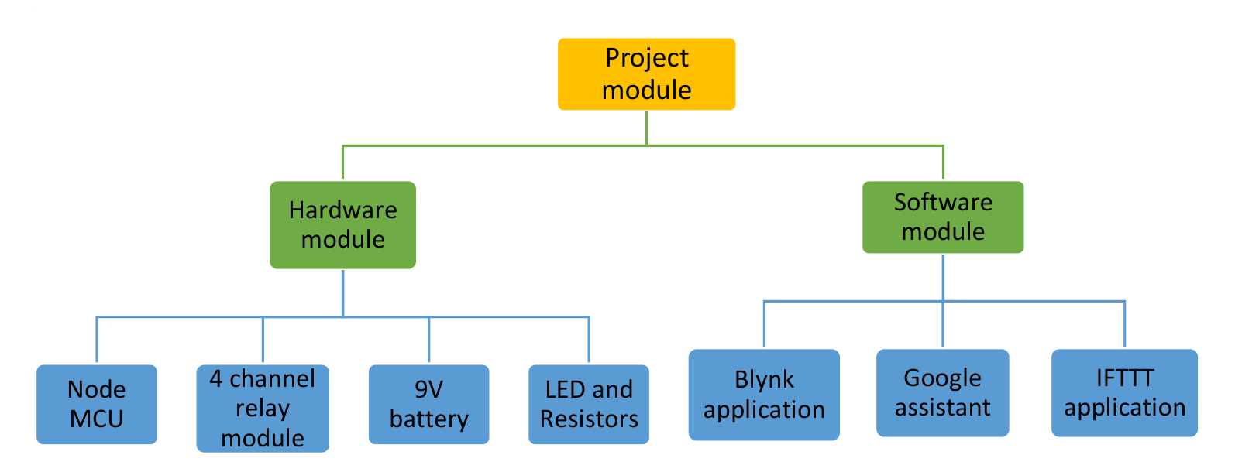
Figure 2.1 Layout of project module

2.3.1 Brief Description
Amplitude Modulation Project: Components and Need An amplitude modulation (AM) system is an electronic circuit used to transmit information by varying the amplitude of a high frequency carrier wave in proportion to a low frequency message signal. It ensures that audio or data signals can be carried over long distances and then recovered at the receiver end. The project involves designing and implementing both a modulator and a demodulator circuit that can reliably encode and decode signals. Such a system is essential for demonstrating the fundamentals of analog communication and has applications in radio broadcasting, educational experiments, and basic communication setups.
- Transistor (Modulator Element)
- Purpose: Acts as a nonlinear device to combine the carrier and message signals, producing the AM waveform.
- Example: An NPN transistor such as 2N2222 or BC547 can be used for modulation.
- Diode (Envelope Detector)
- Purpose: Recovers the original message signal by tracing the envelope of the modulated waveform.
- Example: A small signal diode like 1N4148 is commonly used in envelope detectors.
- Capacitor (Filter Element)
- Purpose: Smooths the demodulated signal by filtering out high frequency components.
- Example: Electrolytic or ceramic capacitors (e.g., 10 µF) are used depending on the design.
- Resistors (Biasing and Load Control)
- Purpose: Provide biasing for the transistor and set load conditions for stable operation.
- Example: Standard resistors (e.g., 1 kΩ, 10 kΩ) are used for biasing and feedback networks.

2.3.2 Block Diagram of the Proposed System

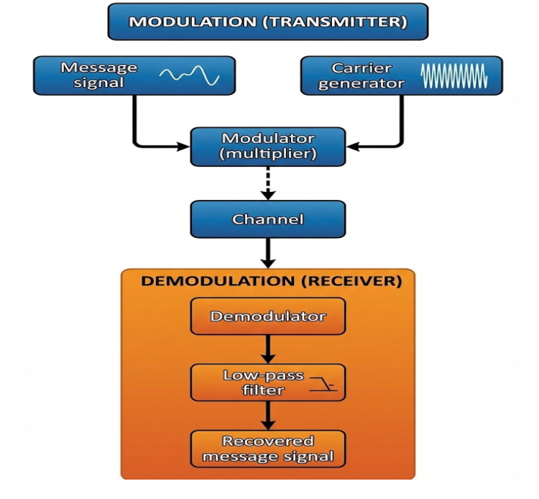
Figure 2.2 Block Diagram of Amplitude Modulator And Demodulator

2.3.3 Working of the system
1. Message Signal
The message signal is a low-frequency baseband signal that contains the actual information (such as audio) to be transmitted. This signal is applied at the input of the system.
2. Carrier Signal
A high-frequency carrier signal is generated using an oscillator. This carrier helps in efficient long-distance transmission of the message signal.
3. Modulator (Multiplier)
The message signal and carrier signal are fed to the modulator. In this stage, the amplitude of the carrier is varied according to the instantaneous value of the message signal, producing an Amplitude Modulated (AM) signal.
4. AM Signal Transmission
The generated AM signal is transmitted through the communication channel. The carrier frequency remains constant while its amplitude carries the information.
5. Envelope Detector
At the receiver, the AM signal is applied to an envelope detector consisting of a diode and RC network. This circuit rectifies the signal and extracts its envelope.
6. Low Pass Filter
The low-pass filter removes high-frequency carrier components from the detected signal, allowing only the original message signal to pass.
7. Recovered Message Signal
After filtering, the original low-frequency message signal is recovered at the output, closely matching the transmitted input signal.
2.3.4 Working of the AM Demodulator
At the receiver section, the demodulation process is carried out to recover the original message signal. The most commonly used technique for AM demodulation is the envelope detector, which operates in the following steps:
• Rectification (Diode Action):
The received AM signal is an alternating waveform. The diode allows only the positive half
cycles of the signal to pass while blocking the negative half-cycles. This converts the signal
into a pulsating DC waveform whose peaks follow the envelope of the original message.
• Peak Detection (Capacitor Action):
A capacitor connected after the diode charges up to the peak value of each incoming pulse.
This helps in tracking the envelope of the modulated signal.
• Filtering (RC Network):
Between successive peaks, the capacitor slowly discharges through the resistor. The RC
values are selected such that the capacitor does not discharge completely between cycles but
is able to follow the variations of the message signal. This filtering action removes the high
frequency carrier components and leaves behind the original low-frequency message signal

Chapter 03: Hardware and Software Requirements

TINA Design Software

Artificial Intelligence (AI) is one of the most significant technological advancements of our time, with the potential to revolutionize various fields, including circuit simulation and design. Since the release of TINA v15 and its online version TINA Cloud, AI has been integrated into both versions as a powerful tool, enabling users to specify and execute tasks with a user-friendly NLP interface, gain valuable insights into circuit behavior, and even generate educational content like test questions and riddles. This integration of AI, accessible both online and offline, empowers users to maximize the potential of TINA.
TINA Design Suite is a powerful yet affordable software package for analyzing, designing and real time testing circuits with analog, RF & MW, digital & microcontroller components and components defined in various Hardware Description Languages, VHDL, VHDL-AMS, Verilog, Verilog A, Verilog AMS, System Verilog, System C and for designing their PCB layouts. You can also analyze RF, communication, optoelectronic circuits and mechatronics applications with a 3D interface.
In TINA 10 and later versions you can create and simulate multidisciplinary designs. Disciplines now include electronics, 3D mechanics and control engineering. This opens a rich new field of applications in automotive engineering, sensing and control, automation, robotics and more.
A unique feature of TINA permits you to bring your circuit to life with the optional USB controlled TINA Lab II and Lab-Xplore hardware that turns your computer into a powerful, multifunction T&M instrument. With Lab-Explorer, you can carry out remote measurements which is great for distance education.
TINA is distributed in two major versions – TINA Standard and TINA Design Suite. TINA Standard includes circuit simulation only, while TINA Design Suite also includes the advanced PCB designer. This fully integrated layout module has all the features you need for advanced PCB design, including Multilayer flexible PCBs with split power planes, powerful auto placement & auto routing, rip-up and reroute, manual” follow-me” trace placement, DRC, forward and back annotation, pin and gate swapping, keep-in and keep-out areas, thermal relief, fanout, plane layers, Gerber file output and much more. TINA and TINA Design Suite also have different editions tailored to customer needs. Some HDL languages and the Mechatronics extension are optional. Both the Standard and the Design Suite versions are provided in 64-bit and 32-bit editions.
TINA can also be used in the training environment. It includes unique tools for testing students’ knowledge, monitoring progress and introducing troubleshooting techniques. With optional hardware it can be used to test real circuits for comparison with the results obtained from simulation. Of great importance to educators, the package includes all the tools needed to prepare educational materials.

Schematic Capture
Circuit diagrams are entered using an easy-to-use schematic editor. Component symbols chosen from the Component bar are positioned, moved, rotated and/or mirrored on the screen by the mouse. TINA’s semiconductor catalog allows the user to select components from a user-extendible library. An advanced “rubber wire” tool is provided allowing easy modification of the schematic diagrams. You can open any number of circuit files or subcircuits, cut, copy and paste circuit segments from one circuit into another, and, of course, analyze any of the currently open circuits. TINA gives you tools to enhance your schematic by adding graphics elements such as lines, arcs, arrows, frames around the schematic, and title blocks. You can also draw non-orthogonal (diagonal) components such as bridges and 3-phase networks.

Live 3D Breadboard Tool
You can take your design for a solderless breadboard (sometimes called a “whiteboard”) and automatically build a life-like 3D picture of the breadboard. Now when you run TINA in interactive mode, virtual components such as switches, LEDs, instruments, etc. become “live” and will function with satisfying realism. Students will use the Live 3D Breadboard tool to prepare and document eye-catching lab experiments.

PCB Design
TINA Standard includes only circuit simulation, while TINA Design Suite includes TINA’s advanced PCB designer. This fully integrated layout module has all the features you need for advanced PCB design, including Multilayer PCB’s with split power planes, powerful auto-placement & auto-routing, rip-up and reroute, manual and ”follow-me” trace placement, DRC, forward and back annotation, pin and gate swapping, keep-in and keep-out areas, thermal relief, fanout, plane layers, bus & differential drawing tools, circuit block copying, 3D view from any angle, and much more. With TINA Design Suite you can prepare a PCB in at least two ways: using the G-Code control files to make in-house prototypes with milling machines using the G-Code control files provided by TINA; or sending Gerber files to PCB manufacturers.

Electrical Rules Check (ERC)
ERC will examine the circuit for questionable connections between components and display the results in the Electrical Rules Check window. ERC is invoked automatically, so missing connections will be brought to your attention before analysis begins.

Schematic Symbol Editor
In TINA, you can simplify a schematic by turning portions of it into a subcircuit. In addition, you can create new TINA components from any Spice subcircuit, whether created by yourself, downloaded from the Internet, or obtained from a manufacturer’s CD. TINA automatically represents these subcircuits as a rectangular block on your schematic, but you can create any shape you like with TINA’s Schematic Symbol Editor.

Library Manager
TINA has large libraries containing Spice- and S-parameter models provided by semiconductor manufacturers such as Analog Devices, Texas Instruments, National Semiconductor, and others. You can add more models to these libraries or create your own Spice- and S-parameter library using TINA’s Library Manager (LM).

IBIS model Support
IBIS (Input/output Buffer Information Specification) is a method to provide modeling information about the input/output buffers of integrated circuits. The good thing about IBIS models is that they are often available even for devices where complete device models are not available from manufacturers. One of the most popular uses of IBIS models is Signal Integrity Analysis, including impedance matching and more. TINA currently supports the most widely used IBIS 4.2 version. In TINA you can convert IBIS models to Spice macros and then use them in any circuits in TINA. You can also complete simplified digital device models e.g. MCUs with IBIS models to better describe their analog behavior. The use of IBIS models in detail is described in the Advance Topics Manual of TINA.

Results and Analysis of Results in TINA

DC analysis
DC analysis calculates the DC operating point and the transfer characteristic of analog circuits. The user can display the calculated and/ or measured nodal voltages at any node by selecting the node with the cursor. For digital circuits, the program solves the logic state equation and displays the results at each node step-by-step.

Transient analysis
In the transient and mixed mode of TINA you can calculate the circuit response to the input waveforms that can be selected from several options (pulse, unit step, sinusoidal, triangular wave, square wave, general trapezoidal waveform, .WAV file, White noise and user-defined excitation) and parameterized as required. For digital circuits, programmable clocks and digital signal generators are available. Power dissipation end efficiency calculations are also included.

Piecewise Linear (PWL) Solver
From v14, in addition to Spice solver TINA also includes a PWL (Piecewise Linear) solver. A unique feature of TINA is that it automatically creates the PWL models of semiconductors in PWL mode. This provides up to 10 times faster solution depending on the structure of the Spice models. You can find examples of PWL analysis with explanations in the Examples\PWL folder of TINA v14. The solver for PWL analysis can be selected in the Options dialog of the Analysis menu of TINA.

Auto convergence.
Convergence that is obtaining a solution is one of the most complicated tasks in circuit simulation due to the strongly nonlinear nature of electronic circuits. Although TINA is one of the best converging simulator software on the market, sometimes manual parameter settings might be needed to achieve convergence. There are several analysis parameter sets are available to be used in case of convergence problems. In TINA 12 and later versions In TINA v12 and later versions these parameter sets are automatically applied in case of need and the user can also add more settings.

Transient Noise Analysis.
Noise effects are usually simulated with linear AC noise analysis which is also available in TINA. However, when the noise influences the system behavior in a nonlinear way, linear noise analysis is no more satisfactory and transient noise analysis that is simulation in the time domain is necessary. A few examples:
- Analysis of systems with low signal-to-noise ratio
- Noise analysis of oscillator circuits
- Analysis of noise effects in digital circuits
The voltage and current generators of TINA now include a parameterizable white noise signal, and application circuits are available to generate other typical noise signals, which makes transient noise analysis possible.

Fourier analysis
In addition to the calculation and display of the response, the coefficients of the Fourier series, the harmonic distortion for periodic signals, and the Fourier spectrum of non-periodic signals can also be calculated.

Digital Simulation
TINA now includes a very fast and powerful simulator for digital circuits. You can trace circuit operation step-by- step, forward and backward, or view the complete time diagram in a special logic analyzer window. In addition to logic gates, there are ICs and other digital parts from TINA’s large component library.

HDL simulation
TINA now includes all major analog, digital and mixed Hardware Description Languages: VHDL, VHDL-AMS, Verilog, Verilog A, Verilog AMS, System Verilog and System C to verify designs in analog, digital and mixed-signal analog-digital environments. Your circuits can contain editable HDL blocks from the libraries of TINA and Xilinx or other HDL components created by yourself or downloaded from the Internet. TINA compiles HDL into highly efficient machine code for speed optimization. You can freely combine HDL and Spice macros and the schematic components of TINA. Also, you can edit the VHDL, Verilog, Verilog A&AMS source of HDL components then simulate and see the result instantly. With the built in HDL debugger you can execute VHDL, Verilog, Verilog A&AMS components step-by-step, add breakpoints, watchpoints, dis- play variable information, etc. The System C source components you can edit and compile with MS Visual C and then add to TINA as high performance compiled components. Examples for use of different HDL languages are available under the Examples\HDL folder of TINA 14 and higher versions.

Microcontroller (MCU) simulation
TINA includes a wide range of microcontrollers (PIC, AVR, 8051, HCS, ARM, XMC) which you can test, debug and run interactively. The built in MCU assembler allows you to modify your assembler code and see the result promptly. You can also program and debug MCUs in C, using external C compilers including the MPLAB-XC compilers. In TINA v12 and later versions more than 1400 MCU models are available in TINA for simulation and PCB design.

Flowchart Editor and Debugger
Writing MCU assembly code is often a hard and tedious task. You can simplify software development and gain more time to design the electronics hardware if, instead of manual coding, you use TINA’s Flowchart editor and debugger to generate and debug the MCU code. This easy-to-use tool works with symbols and flow control lines with which you can represent the algorithm you want. TINA also supports other code generators, the free-of-charge XMC code generation platform DAVE from Infineon Technologies and the FLOWCODE graphical programming language from Matrix Technology Solutions Limited.

AC analysis
AC analysis calculates complex voltage, current, impedance, and power. In addition, Nyquist and Bode diagrams of the amplitude, phase and group delay characteristics of analog circuits can be plotted. You can also draw the complex phasor diagram. For non-linear networks, the operating point linearization is done automatically.

Network analysis
Network analysis determines the two-port parameters of networks (S, Z, Y, H). This is especially useful if you work with RF circuits. Results can be displayed in Smith, Polar, or other diagrams. The network analysis is carried out with the help of TINA’s network analyzer. The RF models of the circuit elements can be defined as SPICE subcircuits (SPICE macros) which contain parasitic components (inductors, capacitors) or as an S-parameter model defined by its S (frequency) function. S functions are normally provided by the component manufacturers (based on their measurements) and can be downloaded from the Internet and inserted into TINA either manually or by using TINA’s library manager. In TINA v14 new S-parameter models such as Circulator, Directional Couplers and more have been included. Examples with RF components are included in the Examples\RF folder.

Analytic SMPS and other device modeling
Using the powerful features of TINA Interpreter and the integrated Python language lighting fast simulation and design of SMPS circuits became possible. This is especially important for semiconductor manufacturers and their customers for quick initial design and simulation of devices. In TINA Industrial v14 both Spice, HDL and Analytic modeling is possible. You can find examples in the Examples\Design Tool folder.

Linear AC Noise Analysis
Linear AC Noise Analysis determines the noise spectrum with respect to either the input or the output. The noise power and the signal-to-noise ratio (SNR) can also be calculated.

Design Tool
This powerful tool works with the design equations of your circuit to ensure that the specified inputs result in the specified output response. The tool offers you a solution engine that you can use to solve repetitively and accurately for various scenarios. The calculated component values are automatically set in place in the companion TINA schematic and you can check the result by simulation. This feature is also very useful for semiconductor and other electronics component manufacturers to provide application circuits along with the design procedure.

Optimization
TINA’S enhanced optimization tool can tweak one or more unknown circuit parameters to achieve a predefined target response. The target circuit response (voltage, current, impedance, or power) must be “monitored” by meters. For example, you can specify several working point DC voltages or AC transfer function parameters and have TINA determine the values of the selected components.

Post-processor
Another great new tool of TINA is its post-processor. With the post-processor, you can add new curves of virtually any node and component voltage or current to existing diagrams. In addition, you can post-process existing curves by adding or subtracting curves, or by applying mathematical functions to them. You can also draw trajectories; i.e., draw any voltage or current as a function of another voltage or current.

Presentation
With TINA you can make quality documents incorporating Bode plots, Nyquist, Phasor, Polar and Smith diagrams, transient responses, digital waveforms and other data using linear or logarithmic scales. Customize presentations easily using TINA’s advanced drawing tools-you can print your plots directly from TINA, cut and paste them into your favorite word processing package, or export them to popular standard formats. Customization includes complete control over texts, axes, and plot style; e.g., setting line width and color, fonts in all sizes and color, and automatic or manual scaling for each axis.

Program Versions Available
Different program versions, tailored to meet various needs, are available. TINA is distributed into major versions TINA and TINA Design Suite. TINA includes simulation only while TINA Design Suite includes our new advanced PCB designer too. Both versions are available with the following features:
- Industrial version: Includes all of TINA’s features and utilities.
- Network version: TINA can be used under most well-known networks including Microsoft, Linux, Novell, Citrix and more.
- Educational version: It has most features of the Industrial version but parameter stepping, and optimizations are allowed for one parameter only, Stress Analysis and the Steady State Solver are not included.
- Classic Edition: It has the same features as the educational version above, except that Network Analysis is not allowed, TINA’s large S-parameter component library and Parameter Extractor, Stress Analysis and the Steady State Solver are not included. IBIS model support, Dissipation and Efficiency calculation and the Auto convergence tool are not included.
- Student Version: Has the same features as the Classic Edition version except that the circuit size is limited to 100 nodes including internal Spice macro nodes. The number of pads on the PCB layout is also limited to 100. Global Parameters and HDL extensions are not allowed.
- Basic version: Has the same features as Classic Edition except that the circuit size is limited to 200 nodes including internal Spice macro nodes. The number of pads on the PCB layout is also limited to 200. Global Parameters and HDL extensions are not allowed.
- Basic Plus version: Has the same features as Classic Edition except that the circuit size is limited to 800 nodes including internal Spice macro nodes. The number of pads on the PCB layout is also limited to 800. Global Parameters and HDL extensions are not allowed.

List of New features in TINA
  - Built-in AI Assistant tool for intelligent design, control, and information gathering
  - Ability to run AI offline without internet connection or with cloud-based AI services.
  - Designing LDO and SMPS power supply circuits
  - Selecting and redesigning evaluation circuits from various manufacturers
  - Active and passive filter design
  - Analog and Digital Oscillator Design
  - Automatic generation of Arduino C code
  - Automatic Quiz and Riddle generation for education and training
  - AI Image Recognition using Python
  - AI Image Recognition using microcontroller code
  - AI driven simulation and robot control
  - AI-powered step-by-step solutions for analyzing simple DC/AC circuits
  - Component activation/deactivation
  - Fourier spectrum processing in the Interpreter
  - Diagram processing functions, filtering and smoothing
  - Advanced multi-sine analysis with pulse response
  - New oscillator and timer circuits

The Basic Screen Format

After start-up, the following screen appears on your monitor:
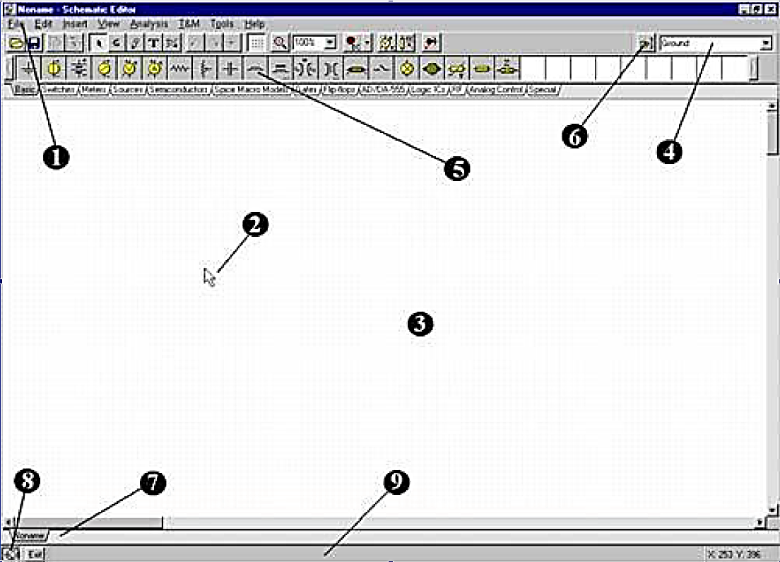
Figure 3.1 Layout of TINA Window
- The Menu bar
- The Cursor or pointer: This is used to select commands and to edit schematics. You can move the cursor only with the mouse.
Depending on the mode of operation, the cursor assumes one of the following forms:
An arrow, when a command selection is required in the edit window.
A component symbol (accompanied by an arrow and small box), when inserting that component onto the circuit in the schematic window. Until the position of the component on the schematic is chosen, its movement is controlled by the mouse.
A pen, when defining the endpoint of a wire. An elastic line, when defining the endpoint of a wire or the second node of an input or output.
An elastic box, when defining a block after fixing its first corner. A dashed line box, when positioning a component label or a text block. A magnifying glass, when defining a zoom window.
- The Schematic window: This shows the circuit schematic currently being edited or analyzed. The schematic window is actually a window onto a larger drawing area. You can move the screen window over the full drawing area using the scroll bars at the right and bottom of the screen. When selecting the new command on the File menu, the system automatically aligns the origin of the editor window with the center of the entire editor drawing area. The same is true when an existing circuit file is loaded, as this is the default window position.
You can think of TINA’s schematic as existing on several “layers.” In addition to the primary layer that holds components, wires, and text, there are two other drawing layers, which you can turn on or off individually. It is generally convenient to have these two layers on.
View Pin Markers On/Off: Displays/hides component pin ends.
View Grid On/Off: Displays/hides the grid.
A grid of closely spaced dots covering the entire drawing area may be made visible or invisible in the schematic window, depending on the current state of the grid button of the Grid On/Off switch on the View menu. At some schematic zoom levels, you will not see the dots of the grid; nevertheless, all component pins and connecting wires will be on the grid. These dots represent the only available interconnecting points. Component symbols are positioned on the drawing area horizontally and vertically. These symbols are rigid patterns with predefined pin positions and are handled as single units. This permits the software to unambiguously recognize the network nodes.
- The Toolbar: You can select most of the editor commands (e.g., select, zoom, wire etc.,) from this toolbar. Let’s summarize the most important commands on the Toolbar. You can find more detailed information in TINA’s Help system. Note that most commands on the toolbar can also be found under the drop-down menus, and can often be activated by Hotkeys. We show the menu name separated from the command name by a dot (Menu name. Command name).
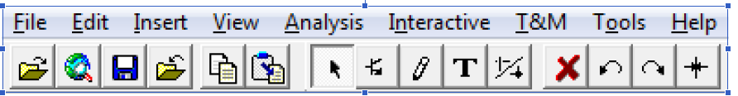
- The Component bar: Components are arranged in groups, named by the tabs on the Component bar. Once you have selected a group, the available component symbols appear above the tabs. When you click on the desired component (and release the button), the cursor changes to that component symbol and you can move it anywhere in the drawing area. You can also rotate the component by pressing the + or - keys (on your computer’s numeric keypad) or mirror it by pressing the asterisk (*) key (also on your computer’s numeric keypad). Once you have selected the part’s position and orientation, press the left button of the mouse to lock the symbol in place.
- Find component tool: This tool helps you find by name any component in the TINA catalog. See more details above at the toolbar description.
- Open files tab: You can have several different circuit files or different parts (macros) of a circuit open in the schematic editor at the same time. Clicking on a tab brings that circuit page up in the editor.
- The TINA Taskbar: TINA’s Taskbar appears at the bottom of the screen and provides speed buttons for the various tools or T&M instruments currently in use. Each tool or instrument operates in its own window and can be made active by clicking on its speed button (icon of the tool). Once the cursor is over the speed button, a brief hint appears. Note that the first button (furthest to the left), the Lock schematic button, has a special function. When the Lock schematic button is pressed, the schematic window is locked in place as a background behind other windows, so that it can never cover a diagram or virtual instruments. When the schematic window is not locked and it is currently selected, you will always see the entire schematic window with any other windows hidden behind.
- The Help line: The Help line, at the bottom of the screen, provides short explanations of items pointed to by the cursor.

3.6 Operational Amplifier
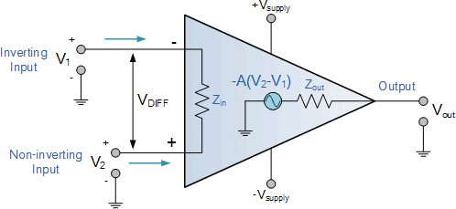
Figure 3.2 Basic Structure of OPAMP
Operational Amplifiers, or Op-amps as they are more commonly called, are one of the basic building blocks of Analogue Electronic Circuits.
Operational amplifiers are linear devices that have all the properties required for nearly ideal DC amplification and are therefore used extensively in signal conditioning, filtering or to perform mathematical operations such as add, subtract, integration and differentiation.
An Operational Amplifier, or op-amp for short, is fundamentally a voltage amplifying device designed to be used with external feedback components such as resistors and capacitors between its output and input terminals. These feedback components determine the resulting function or “operation” of the amplifier and by virtue of the different feedback configurations whether resistive, capacitive or both, the amplifier can perform a variety of different operations, giving rise to its name of “Operational Amplifier”.

An Operational Amplifier is a three-terminal device that consists of two high-impedance inputs. One of the inputs is called the Inverting Input, marked with a negative or “minus” sign, (–). The other input is called the Non-inverting Input, marked with a positive or “plus” sign (+).
A third terminal represents the operational amplifiers output port which can both sink and source either a voltage or a current. In a linear operational amplifier, the output signal is the amplification factor, known as the amplifier gain (A) multiplied by the value of the input signal, and depending on the nature of these input and output signals, there can be four different classifications of operational amplifier gain.
- Voltage – Voltage “in” and Voltage “out”
- Current – Current “in” and Current “out”
- Transconductance – Voltage “in” and Current “out”
- Trans-resistance – Current “in” and Voltage “out”
The output voltage signal from an Operational Amplifier is the difference between the signals being applied to its two individual inputs. In other words, an op-amps output signal is the difference between the two input signals as the input stage of an Operational Amplifier is in fact a differential amplifier as shown below.

Differential Amplifier
The circuit below shows a generalized form of a differential amplifier with two inputs marked V1 and V2. The two identical transistors TR1 and TR2 are both biased at the same operating point with their emitters connected together and returned to the common rail, - Vee by way of resistor Re.
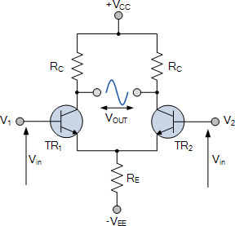
Figure 3.3 Differential Amplifier
The circuit operates from a dual supply +Vcc and -Vee which ensures a constant supply. The voltage that appears at the output, Vout of the amplifier, is the difference between the two input signals as the two base inputs are in anti-phase with each other.
So as the forward bias of transistor, TR1 is increased, the forward bias of transistor TR2 is reduced and vice versa. Then if the two transistors are perfectly matched, the current flowing through the common emitter resistor, re will remain constant.

Like the input signal, the output signal is also balanced and since the collector voltages either swing in opposite directions (anti-phase) or in the same direction (in-phase) the output voltage signal, taken from between the two collectors is, assuming a perfectly balanced circuit the zero difference between the two collector voltages.
This is known as the Common Mode of Operation with the common mode gain of the amplifier being the output gain when the input is zero.
Operational Amplifiers also have one output (although there are ones with an additional differential output) of low impedance that is referenced to a common ground terminal and it should ignore any common mode signals that is, if an identical signal is applied to both the inverting and non-inverting inputs there should no change to the output.
However, in real amplifiers, there is always some variation, and the ratio of the change to the output voltage with regards to the change in the common mode input voltage is called the Common Mode Rejection Ratio or CMRR for short.
Operational Amplifiers on their own have a very high open loop DC gain and by applying some form of Negative Feedback we can produce an operational amplifier circuit that has a very precise gain characteristic that is dependent only on the feedback used. Note that the term “open loop” means that there is no feedback components used around the amplifier so the feedback path or loop is open.
An operational amplifier only responds to the difference between the voltages on its two input terminals, known commonly as the “Differential Input Voltage” and not to their common potential. Then if the same voltage potential is applied to both terminals the resultant output will be zero. An Operational Amplifiers gain is commonly known as the Open Loop Differential Gain and is given the symbol (Ao).

Equivalent Circuit of an Ideal Operational Amplifier
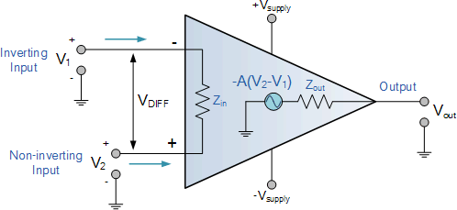
Figure 3.4 Equivalent Circuit of OPAMP

Op-amp Parameter and Idealized Characteristic

Open Loop Gain, (Avo)
Infinite – The main function of an operational amplifier is to amplify the input signal, and the more open loop gain it has the better. Open-loop gain is the gain of the op-amp without positive or negative feedback and for such an amplifier the gain will be infinite but typical real values range from about 20,000 to 200,000.

Input impedance, (ZIN)
Infinite – Input impedance is the ratio of input voltage to input current and is assumed to be infinite to prevent any current flowing from the source supply into the amplifiers input circuitry (IIN = 0). Real op-amps have input leakage currents from a few pico-amps to a few milli-amps.

Output impedance, (ZOUT)
Zero – The output impedance of the ideal operational amplifier is assumed to be zero acting as a perfect internal voltage source with no internal resistance so that it can supply as much current as necessary to the load. This internal resistance is effectively in series with the load thereby reducing the output voltage available to the load. Real op-amps have output impedances in the 100-20kΩ range.

Bandwidth, (BW)
Infinite – An ideal operational amplifier has an infinite frequency response and can amplify any frequency signal from DC to the highest AC frequencies, so it is therefore assumed to have an infinite bandwidth. With real op-amps, the bandwidth is limited by the Gain-Bandwidth product (GB), which is equal to the frequency where the amplifiers gain becomes unity.

Offset Voltage, (V_{IO})
Zero – The amplifiers output will be zero when the voltage difference between the inverting and the non-inverting inputs is zero, the same or when both inputs are grounded. Real op-amps have some output offset voltage.

From these “idealized” characteristics above, we can see that the input resistance is infinite, so no current flows into either input terminal (the “current rule”) and that the differential input offset voltage is zero (the “voltage rule”). It is important to remember these two properties as they will help us understand the workings of the Operational Amplifier with regard to the analysis and design of op-amp circuits.
However, real Operational Amplifiers such as the commonly available uA741, for example, do not have infinite gain or bandwidth but have a typical “Open Loop Gain” which is defined as the amplifiers output amplification without any external feedback signals connected to it and for a typical operational amplifier is about 100dB at DC (zero Hz). This output gain decreases linearly with frequency down to “Unity Gain” or 1, at about 1MHz and this is shown in the following open-loop gain response curve.

Open-loop Frequency Response Curve
From this frequency response curve, we can see that the product of the gain against frequency is constant at any point along the curve. Also, the unity gain (0dB) frequency also determines the gain of the amplifier at any point along the curve. This constant is generally known as the Gain Bandwidth Product or GBP. Therefore:
GBP = Gain x Bandwidth = A x BW
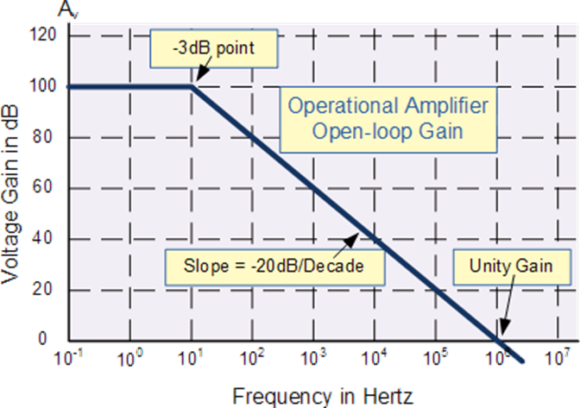
Figure 3.5 Open-Loop Frequency Response Curve of OPAMP
For example, from the graph above the gain of the amplifier at 100kHz is given as 20dB or 10, then the gain bandwidth product is calculated as:
GBP = A x BW = 10 x 100,000Hz = 1,000,000.
Similarly, the operational amplifiers gain at 1kHz = 60dB or 1000, therefore the GBP is given as:
GBP = A x BW = 1,000 x 1,000Hz = 1,000,000.
The Voltage Gain (AV) of the operational amplifier can be found using the following formula:
$$Voltage Gain, A=\frac{V_{out}}{V_{in}}$$
and in Decibels or (dB) is given as:
$$20\log\left(A\right)or 20 log\frac{V_{out}}{V_{in}} in dB$$

An Operational Amplifiers Bandwidth
The operational amplifier bandwidth is the frequency range over which the voltage gain of the amplifier is above 70.7% or -3dB (where 0dB is the maximum) of its maximum output value as shown below.
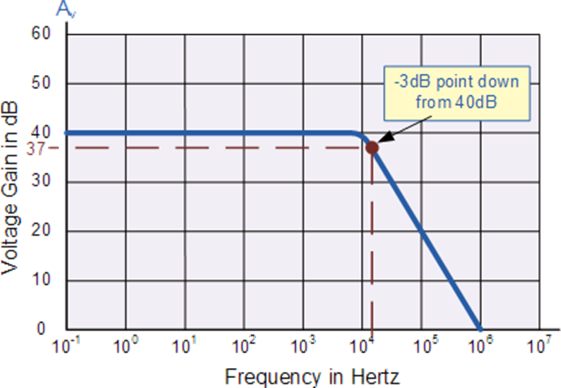
Figure 3.6 Determination of Cutoff Frequency from Frequency Response Curve of OPAMP
Here we have used the 40dB line as an example. The -3dB or 70.7% of Vmax down point from the frequency response curve is given as 37dB. Taking a line across until it intersects with the main GBP curve gives us a frequency point just above the 10kHz line at about 12 to 15kHz. We can now calculate this more accurately as we already know the GBP of the amplifier, in this particular case 1MHz.

Ideal characteristics of an Op-Amp:
Open Loop gain
Open loop gain is the gain of the Op Amp without positive or negative feedback. An ideal OP Amp should have an infinite open loop gain but typically it ranges between 20,000 and 2, 00000.

Input impedance
It is the ratio of the input voltage to the input current. It should be infinite without any leakage of current from the supply to the inputs. But there will be a few Pico ampere current leakages in most Op-Amps.

Output impedance
The ideal Op Amp should have zero output impedance without any internal resistance. So that it can supply full current to the load connected to the output.
Band-width
The ideal Op Amp should have an infinite frequency response so that it can amplify any frequency from DC signals to the highest AC frequencies. But most Op Amps have limited bandwidth.

Offset
The output of the Op Amp should be zero when the voltage difference between the inputs is zero. But in most Op Amps, the output will not be zero when off but there will be a minute voltage from it.

OPAMP Pin Configuration:
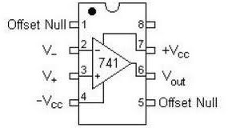
Figure 3.7 Pin Configuration of OPAMP

In a typical Op-Amp there will be 8 pins. These are

Pin1 – Offset Null
Pin2 – Inverting input INV
Pin3 – non-inverting input non-INV
Pin4 – Ground- Negative supply
Pin5 – Offset Null
Pin6 – Output
Pin7 – Positive supply
Pin8 – Strobe

3.11 Bipolar Junction Transistors
Semiconductor devices that have three or more elements are called TRANSISTORS. The term transistor was derived from the words TRANSFER and RESISTOR. This term was adopted because it accurately describes the operation of the transistor, specifically the transfer of an input signal current from a low-resistance circuit to a high-resistance circuit. Basically, the transistor is a solid-state device that amplifies by controlling the flow of current carriers through its semiconductor materials.
There are many different types of transistors, but their basic theory of operation is all the same. The three elements of the two-junction transistor are (1) the EMITTER, which gives off, or emits," current carriers (electrons or holes); (2) the BASE, which controls the flow of current carriers; and (3) the COLLECTOR, which collects the current carriers.

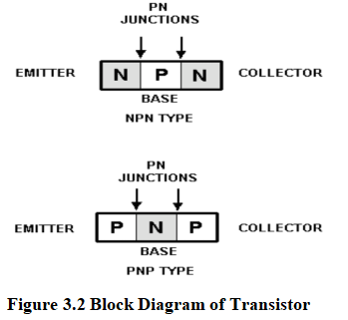
Transistors are classified as NPN or PNP based on the arrangement of N-type and P-type semiconductor material. An NPN transistor has a thin P-type region between two N-type regions. A PNP transistor has a thin N-type region between two P-type regions. These transistors have two PN junctions:
- Between the emitter and the base.
- Between the collector and the base.
The shared base region results in a three-element structure: the emitter, base, and collector.
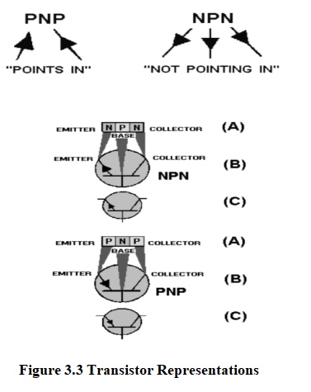
The arrow always points in the direction of hole flow, or from the P to N sections, no matter whether the P section is the emitter or base. On the other hand, electron flow is always toward or against the arrow, just like in the junction diode.

NPN transistor working
For the transistor to function in this capacity, the first PN junction (emitter-base junction) is biased in the forward, or low-resistance, direction. At the same time the second PN junction (base-collector junction) is biased in the reverse, or high resistance, direction. The base of the NPN transistor must be positive with respect to the emitter, and the collector must be more positive than the base.

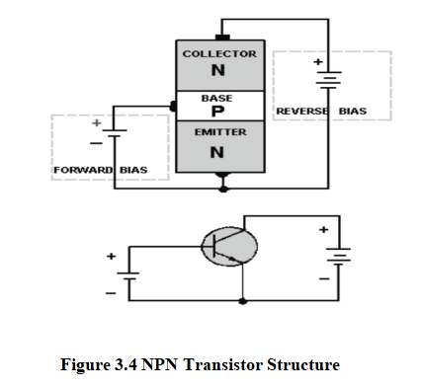
In a forward-biased junction where the N-type material is more heavily doped than the P-type material, majority carrier electrons from the N material carry more current across the junction than the majority carrier holes from the P material. This results in conduction through the forward-biased junction. When the emitter-to-base junction is biased in the forward direction, electrons leave the negative terminal of the battery and enter the N-type material (emitter). Since the N material has majority carrier electrons, they easily pass through the emitter, cross the junction, and combine with holes in the P-type material (base). Each electron that fills a hole in the base creates a new hole as it leaves, and this electron eventually enters the positive terminal of the battery.
In the reverse-biased junction (base-to-collector), the majority current carriers are blocked from crossing the junction. However, a small minority current, or reverse current, does pass through. This current is generated by electron-hole pairs. In the reverse-biased PN junction, the minority carriers are the electrons in the P material and the holes in the N material. These minority carriers conduct the current for the reverse-biased junction by allowing electrons from the P material to enter the N material, and holes from the N material to enter the P material.
In an NPN transistor, the total current flow is through the emitter lead, accounting for 100 percent of the current (IE). Due to the base being very thin and lightly doped, only a smaller percentage of the total current flows through the base circuit, typically around 2 to 5 percent (IB), while the remaining 95 to 98 percent flows through the collector circuit (IC). The fundamental relationship between these currents is given by the equation I_{E}=I_{B}+I_{C}.

$3.11.2$ Transistor Configurations
A transistor may be connected in any one of three basic configurations: common emitter (CE), common base (CB), and common collector (CC). The term common is used to denote the element that is common to both input and output circuits. Because the common element is often grounded, these configurations are frequently referred to as grounded emitter, grounded base, and grounded collector.
- Common Emitter:

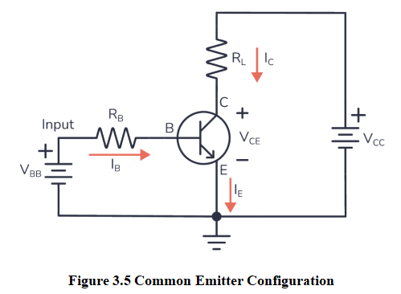
In a common-emitter configuration, the input signal is applied between the base and the emitter. When the input signal swings positive, the base becomes more positive relative to the emitter, reducing the forward bias, decreasing the collector current (IC), and making the collector voltage (VC) more negative. Conversely, when the input signal swings negative, the base becomes more negative relative to the emitter, increasing the forward bias, increasing the collector current, and making the collector voltage less negative or more positive. Notably, the input and output signals are 180 degrees out of phase in this configuration. The common-emitter configuration provides excellent current and voltage gain, with the amplification capability represented by Beta (β), the ratio of collector current (IC) to base current (IB).
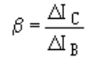
(∆ is the Greek letter delta, it is used to indicate a small change)
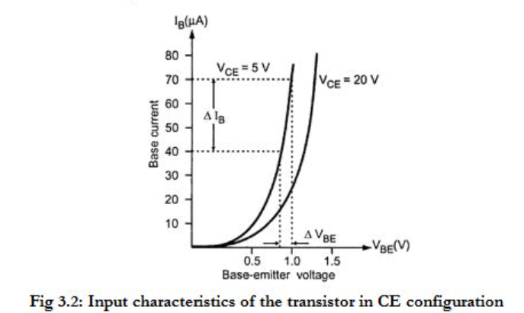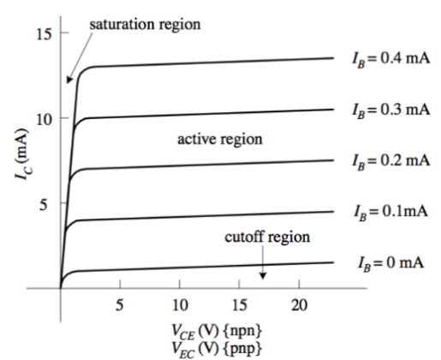
Input characteristics Output characteristics

Figure 3.6 Input and Output Characteristics of Common Emitter Configuration
The circuit operates from a dual supply +Vcc and -Vee which ensures a constant supply. The voltage that appears at the output, Vout of the amplifier, is the difference between the two input signals as the two base inputs are in anti-phase with each other.
So as the forward bias of transistor, TR1 is increased, the forward bias of transistor TR2 is reduced and vice versa. Then if the two transistors are perfectly matched, the current flowing through the common emitter resistor, Re will remain constant.
- Common Base:
In the common-base configuration, the input signal is applied to the emitter, the output is taken from the collector, and the base is the element common to both input and output. Since the input is applied to the emitter, it causes the emitter-base junction to react in the same manner as it did in the common-emitter circuit. For example, an input that aids the bias will increase transistor current, and one that opposes the bias will decrease transistor current. The current gain in the common-base circuit is calculated in a method similar to that of the common emitter except that the input current is IE not IB and the term ALPHA (α) is used in place of beta for gain. Alpha is the relationship of collector current (output current) to emitter current (input current). Alpha is calculated using the formula:
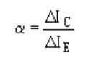
- Common Collector:
The current gain is higher than that in the common emitter, but it has a lower power gain than either the common base or the common emitter. Like the common base, the output signal from the common collector is in phase with the input signal. The common collector is also referred to as an emitter follower because the output developed at the emitter follows the input signal applied to the base.
$$γ=\frac{{∆I}_{E}}{{∆I}_{B}}$$
$$α=\frac{β}{1+β}, β=\frac{α}{1−α}, γ=β+1$$

DC Load Line
When the transistor is given the bias and no signal is applied at its input, the load line drawn under such conditions can be understood as a DC condition. Here, there will be no amplification as the signal is absent. The circuit will be as shown in the figure below.
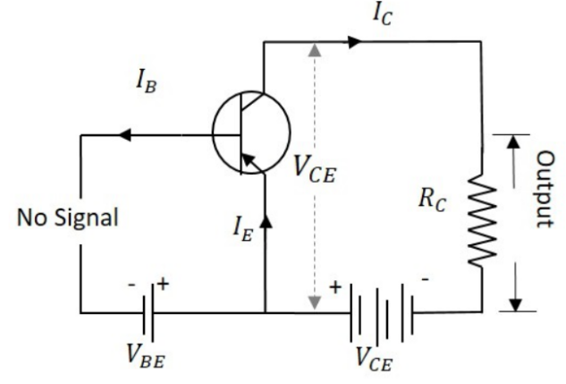
Figure 3.7 Transistor circuit with no input signal
The value of the collector-emitter voltage at any given time will be
V_{CE}=V_{CC}−I_{C}R_{C}
As V_{CC} and R_{C} are fixed values, the above one is a first-degree equation and hence will be a straight line on the output characteristics. This line is called as D.C. Load line. The figure below shows the DC load line.
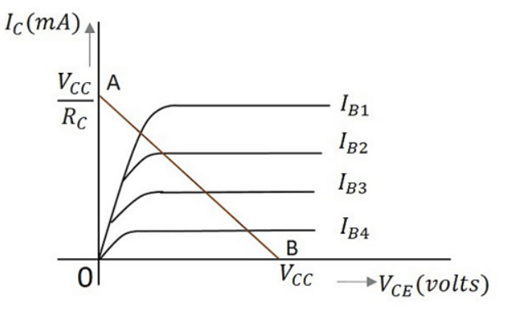
Figure 3.8 DC Load line
To obtain the load line, the two endpoints of the straight line are to be determined. Let those two points be A and B.
To obtain A
When the collector emitter voltage V_{CE} = 0, the collector current is maximum and is equal to V_{CC}/R_{C}. This gives the maximum value of V_{CE}. This is shown as
V_{CE}=V_{CC}−I_{C}R_{C}
0=V_{CC}−I_{C}R_{C}
I_{C}=V_{CC}/R_{C}
This gives point A (OA = V_{CC}/R_{C}) on the collector current axis, shown in the above figure.
To obtain B
When the collector current I_{C} = 0, the collector-emitter voltage is maximum and will be equal to V_{CC}. This gives the maximum value of I_{C}. This is shown as
V_{CE}=V_{CC}−I_{C}R_{C}=V_{CC} (As I_{C} = 0)
This gives point B, which means (OB = VCC) on the collector-emitter voltage axis shown in the above figure. Hence, we determined both the saturation and cutoff points and learned that the load line is a straight line. So, a DC load line can be drawn.
3.11.4 Operating point
When a value for the maximum possible collector current is considered, that point will be present on the Y-axis, which is nothing but the saturation point. As well, when a value for the maximum possible collector emitter voltage is considered, that point will be present on the X-axis, which is the cutoff point.
When a line is drawn joining these two points, such a line can be called as Load line. This is called so as it symbolizes the output at the load. This line, when drawn over the output characteristic curve, makes contact at a point called as Operating point.
This operating point is also called as quiescent point or simply Q-point. There can be many such intersecting points, but the Q-point is selected in such a way that irrespective of AC signal swing, the transistor remains in active region. This can be better understood through the figure below.
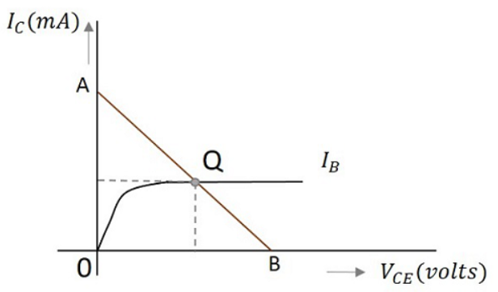
Figure 3.9 Operating Point (Q-Point)
The load line has to be drawn in order to obtain the Q-point. A transistor acts as a good amplifier when it is in active region and when it is made to operate at Q-point, faithful amplification is achieved.
- Faithful Amplification refers to an amplification process where the output signal is an accurate and undistorted reproduction of the input signal, scaled by a constant factor. For a transistor amplifier to achieve faithful amplification, certain conditions must be met:
- Proper Biasing: Ensure the transistor operates in its active region to avoid distortion.
- Stable Operating Point: Maintain a stable Q-point despite temperature changes or power supply-operation.
- Linear Operation: Keep the input signal within the linear region of the transistor's characteristics.
- Appropriate Input Levels: Ensure the input signal amplitude is small enough to stay within the active region.
- Impedance Matching: Match input and output impedances to maximize signal transfer and minimize losses.
- Adequate Power Supply: Provide a stable and sufficient power supply to support the desired output without clipping.
The Beta is not a fixed value and can vary depending on factors such as the transistor type, manufacturing variations, and operating conditions (e.g., temperature, current). Typical Beta values range from 20 to 1000, depending on the transistor. In circuits, the actual current gain depends on how the transistor is configured (common emitter, common base, or common collector) and the specific conditions under which it operates.
why stabilization in transistors is necessary:
- Temperature Compensation: Maintains consistent performance despite temperature changes.
- Operating Point Stability: Ensures the transistor operates correctly within its active region.
- Prevents Thermal Runaway: Reduces the risk of damaging the transistor due to overheating.
- Ensures Consistent Gain: Keeps the gain steady for reliable amplification.
- Addresses Component Variability: Ensures uniform performance despite manufacturing differences.
Therefore, biasing is required.

Biasing in Transistors
Transistor Biasing is the process of setting a transistor's DC operating voltage or current conditions to the correct level so that any AC input signal can be amplified correctly by the transistor. The steady state operation of a bipolar transistor depends a great deal on its base current, collector voltage, and collector current values. Therefore, if the transistor is to operate correctly as a linear amplifier, it must be properly biased around its operating point as improper transistor biasing will result in a distorted output.
Establishing the correct operating point requires selecting bias resistors and load resistors to provide the appropriate input current and collector voltage conditions. The correct biasing point for a bipolar transistor, either NPN or PNP, generally lies somewhere between the two extremes of operation with respect to it being either “fully-ON” or “fully-OFF” along its DC load line. This central operating point is called the “Quiescent Operating Point”, or Q-point for short.
When a bipolar transistor is biased so that the Q-point is near the middle of its operating range, that is, approximately halfway between cut-off and saturation, it is said to be operating as a Class-A amplifier. This mode of operation allows the output voltage to increase and decrease around the amplifier's Q-point without distortion as the input signal swings through one complete cycle. In other words, the output is available for the full 360 ° of the input cycle.

Base-Current Bias (Fixed Bias)
Fixed bias is a common method used to establish the operating point of a transistor. In this configuration, a resistor is connected from the base of the transistor to a fixed voltage supply, usually the same as the collector supply voltage. This setup ensures a constant base current, which in turn sets the collector current and establishes the desired operating point.
The simplicity of the fixed bias method makes it easy to design and implement, especially for low-power circuits and initial stages of multistage amplifiers. However, one drawback is that fixed bias doesn't provide stability against variations in temperature or changes in the transistor's properties. As a result, additional stabilization techniques may be required for reliable operation in fluctuating conditions.
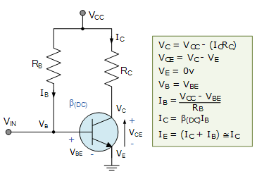
Figure 3.10 Fixed Bias Circuit
The circuit shown is called a “fixed base bias circuit” because the transistor's base current, IB, remains constant for given values of Vcc, and therefore the transistor's operating point must also remain fixed. This two-resistor biasing network is used to establish the initial operating region of the transistor using a fixed current bias.
This type of transistor biasing arrangement is also known as beta-dependent biasing, as the steady-state condition of operation is a function of the transistor's beta (β) value. Consequently, the biasing point will vary over a wide range for transistors of the same type, since their characteristics will not be exactly the same.
The emitter diode of the transistor is forward-biased by applying the required positive base bias voltage via the current-limiting resistor R_{B}. Assuming a standard bipolar transistor, the forward base-emitter voltage drop would be 0.7V. Then the value of R_{B} is simply: (V_{CC} – V_{BE})/I_{B}, where I_{B} is defined as I_{C}/β.
With this single-resistor type of biasing arrangement, the biasing voltages and currents do not remain stable during transistor operation and can vary enormously. Also, the operating temperature of the transistor can adversely affect the operating point.

Self-Bias
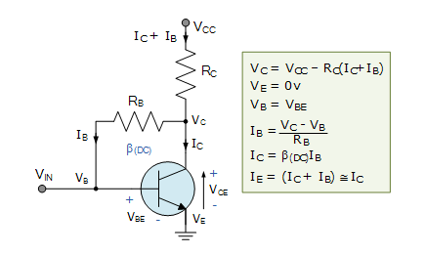
Figure 3.11 Self Bias Circuit
This self-biasing collector feedback configuration is another beta-dependent biasing method that requires two resistors to provide the necessary DC bias for the transistor. The collector to base feedback configuration ensures that the transistor is always biased in the active region, regardless of the value of Beta (β). The DC base bias voltage is derived from the collector voltage V_{C}, thus providing good stability.
In this circuit, the base bias resistor, R_{B}, is connected to the transistor's collector, C, rather than to the supply voltage rail, Vcc. Now, if the collector current increases, the collector voltage drops, reducing the base drive and thereby automatically reducing the collector current to maintain the transistors' Q-point. Therefore, this method of collector feedback biasing produces negative feedback around the transistor, as there is direct feedback from the output terminal to the input terminal via the resistor, R_{B}.
Since the biasing voltage is derived from the voltage drop across the load resistor, R_{L}, if the load current increases, there will be a larger voltage drop across R_{L}, and a corresponding reduced collector voltage, V_{C}. This effect will cause a corresponding drop in the base current, I_{B}, which in turn, brings I_{C} back to normal.
The opposite reaction will also occur when the transistor's collector current reduces. This method of biasing is then referred to as self-biasing, with the transistor's stability achieved through this type of feedback bias network generally being suitable for most amplifier designs.

Voltage divider bias
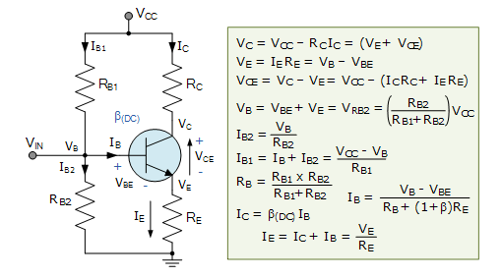
Figure 3.12 Voltage Divider Bias Circuit
Here, the common-emitter transistor configuration is biased using a voltage divider network to enhance stability. The name of this biasing configuration originates from the fact that the two resistors, R_{B1} and R_{B2}, form a voltage divider network across the supply, with their center point junction connected to the transistor's base terminal, as shown.

This voltage divider biasing configuration is the most widely used method for biasing transistors. The emitter diode of the transistor is forward-biased by the voltage value developed across resistor R_{B2}. Also, voltage divider network biasing makes the transistor circuit independent of changes in beta, as the biasing voltages are set at the transistor's base, emitter, and collector terminals and are not dependent on external circuit values.

To calculate the voltage developed across resistor R_{B2} and, therefore, the voltage applied to the base terminal, we simply use the voltage divider formula for resistors in series.
Generally, the voltage drop across resistor R_{B2} is much less than that of resistor R_{B1}. Clearly, the transistor's base voltage, V_{B}, with respect to ground, will be equal to the voltage across R_{B2}.

The amount of biasing current flowing through resistor R_{B2} is generally set to 10 times the value of the required base current I_{B}, so that it is sufficiently high to have no effect on the voltage divider current or changes in Beta.

The goal of Transistor Biasing is to establish a known quiescent operating point, or Q-point, for the bipolar transistor to work efficiently and produce an undistorted output signal. Correct DC biasing of the transistor also establishes its initial AC operating region, using practical biasing circuits with either a two-resistor or a four-resistor bias network.

In bipolar transistor circuits, the Q-point is represented by (V_{CE}, I_{C}) for the NPN transistors or (V_{EC}, I_{C}) for PNP transistors. The stability of the base bias network and therefore the Q-point is generally assessed by considering the collector current as a function of both Beta (β) and temperature.

Here, we have looked briefly at five different configurations for “biasing a transistor” using resistive networks. However, we can also bias a transistor using either silicon diodes, Zener diodes, or active networks, all of which are connected to the transistor's base terminal. We could also bias the transistor correctly from a dual voltage power supply if desired.

Chapter 04: Project Development and Testing Aspects

  - Design Statement:

The aim of this project is to design and implement an Amplitude Modulation (AM) modulator and demodulator system for efficient transmission and reception of analog signals. The design involves generating a high-frequency carrier signal and combining it with a low-frequency message signal in a manner that causes the carrier's amplitude to vary according to the information signal. The modulator circuit is developed using basic electronic components to ensure simplicity, stability, and ease of implementation. At the receiver end, a suitable demodulator is designed to recover the original message signal from the modulated waveform using envelope detection and filtering techniques. The overall design emphasizes clarity of theoretical concepts, practical feasibility, and reliable signal reproduction, thereby providing a comprehensive understanding of the working principles of analog communication systems.

4.2 Circuit and Test Results:
    - Modulation:

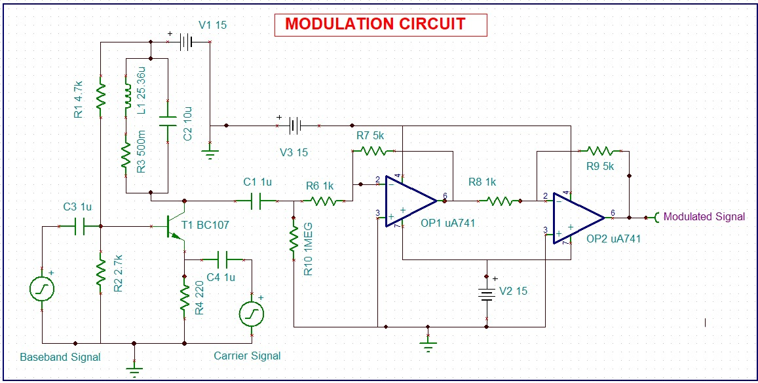
Figure 4.1 Implemented Circuit of AM modulation
4.2.2 Procedure:
In this modulation circuit, a low-frequency baseband signal is applied to the input through the coupling capacitor C3 and biasing network formed by resistors R1,R2,and R3 which ensures proper operating point for the transistor T1 (BC107). The high-frequency carrier signal is coupled to the emitter of the transistor through capacitor C4 and emitter resistor R4. The transistor operates in its active region, where the collector current varies according to the instantaneous amplitude of the baseband signal, thereby controlling the carrier amplitude. The modulated output from the transistor stage is capacitively coupled through C1 and applied to the first operational amplifier (μA741), which provides signal amplification and isolation. A second μA741 op-amp stage is used tdo further amplify and stabilize the modulated signal. Proper power supply biasing of ±15 V is provided to both op-amps to ensure linear operation. The final output obtained at the output of the second op-amp represents the amplitude-modulated (AM) signal, where the carrier envelope follows the shape of the baseband signal, confirming successful amplitude modulation.
    - Modulation Waveform:

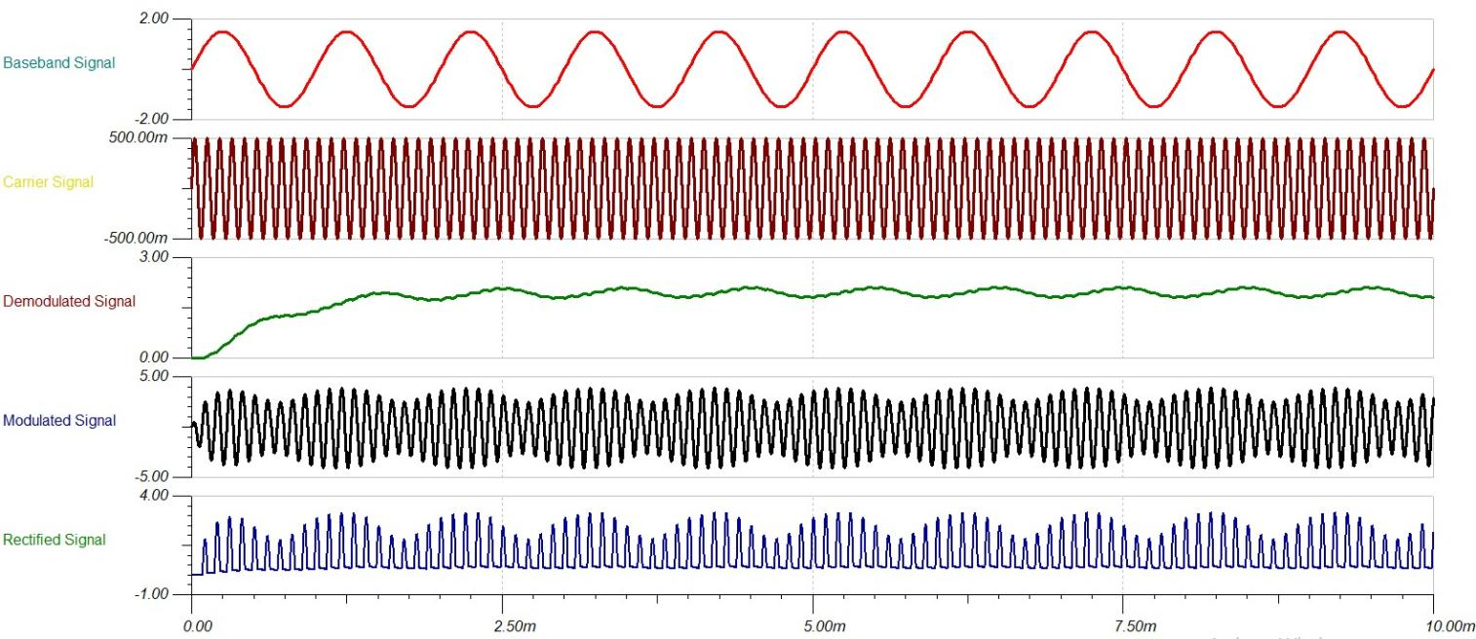
Figure 4.2 Result of AM modulation and Demodulation
4.2.4 AMPLITUDE MODULATION FORMULAS
- BASEBAND (Message) SIGNAL
$v_{m}\left(t\right)=A_{m}cos⁡(ω_{m}t)$ …………. (4.1)
- CARRIER SIGNAL
$v_{c}\left(t\right)=A_{c}cos⁡(ω_{c}t)$ ………… (4.2)
- AMPLITUDE MODULATED SIGNAL (Instantaneous Carrier Amplitude)
$v\left(t\right)=[A_{c}+A_{m}\cos\left(ω_{m}t\right)]cos⁡(ω_{c}t)$ ..………. (4.3)
- STANDARD EQUATION OF AM SIGNAL
$v\left(t\right)=A_{m}(1+m\cos\left(ω_{m}t\right))cos⁡(ω_{c}t)$ …….…… (4.4)
- MODULATED INDEX
$m=\frac{A_{m}}{A_{c}}$ ………… (4.5)
6. CONDITION FOR PROPER AMPLITUDE MODULATION
0< m ≤ 1 ………… (4.6)

4.2.5 DATA GIVEN: -
Baseband (Message) Signal Frequency, = Low frequency (audio range)
Carrier Signal Frequency, = High frequency
Supply Voltage, = 15 V
Transistor Used = BC107
Operational Amplifier Used = µA741
Emitter Resistance, = 220 Ω
Base Bias Resistors = 4.7 kΩ and 2.7 kΩ
Coupling Capacitors = 1 µF

4.2.6 Spectrum:
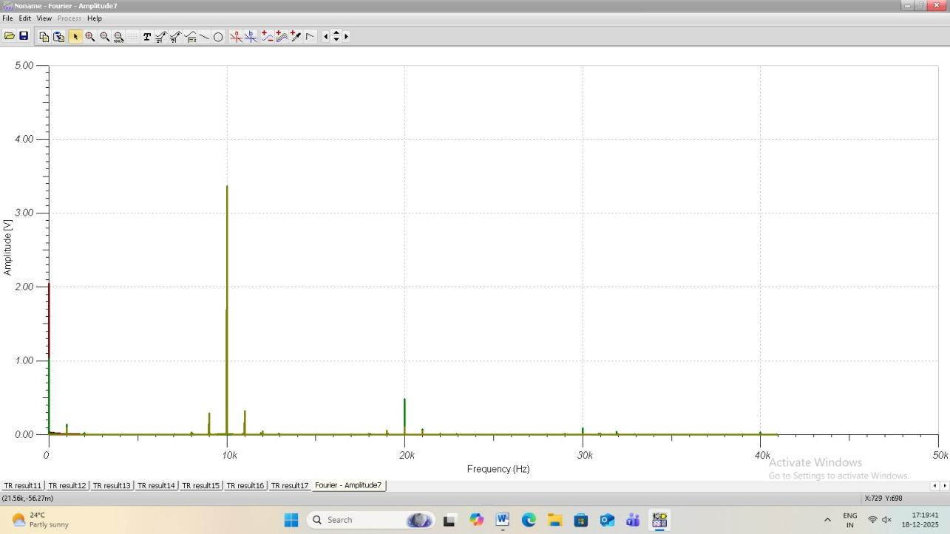
Figure 4.3 Spectrum of AM modulation and Demodulation

The spectrum of a signal represents the distribution of its frequency components in the frequency domain. In Amplitude Modulation (AM), a low-frequency message signal modulates a high-frequency carrier, resulting in a characteristic frequency spectrum. For a single-tone message signal of frequency $f_{m}$modulating a carrier of frequency $f_{c}$, the AM signal consists of three main components:
- Carrier Component
- Appears at frequency $f_{c}$
- Amplitude = $A_{c}$
- Contains no information, but helps in demodulation
- Upper Sideband (USB):
- Appears at frequency $f_{c}+f_{m}$
- Amplitude = $\frac{A_{c}A_{m}}{2}$
- Contains message information.

- Lower Sideband (LSB):
- Appears at frequency $f_{c}−f_{m}$
- Amplitude = $\frac{A_{c}A_{m}}{2}$
- Also contains message information.
Thus, the AM spectrum is symmetrical about the carrier frequency.
- Bandwidth of AM Signal:
The total bandwidth of an AM signal is given by:
$\text{Bandwidth}=(f_{c}+f_{m})−(f_{c}−f_{m})=2f_{m}$ ….………. (4.7)
This shows that AM requires twice the message frequency bandwidth.

Mathematical Representation of spectrum:
$sAM(t)=A_{c}cos⁡(2πf_{c}t)+\frac{A_{c}A_{m}}{2}cos⁡2π(f_{c}+f_{m})t+\frac{A_{c}A_{m}}{2}cos⁡2π(f_{c}−f_{m})$ ….….(4.8)

- Carrier: Ac​cos(2πfc​t)
- USB : Ac​Am/2 ​​cos2π(fc​+fm​)t
- LSB : Ac​Am​​/2 cos2π(fc​−fm​

4.2.7 Demodulation:
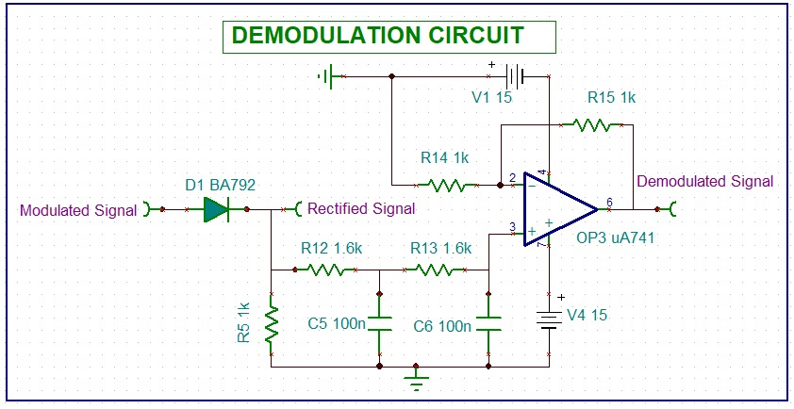
Figure 4.4 Implemented Circuit of AM Demodulation
4.2.8 Procedure:
The demodulation process begins by applying the amplitude-modulated (AM) signal to the input of the demodulation circuit. The modulated signal is first passed through the diode D1 (BA792), which performs rectification and converts the AM waveform into a pulsating DC signal containing the envelope information. This rectified signal is then fed to a low-pass filter network formed by resistors R12,R13, and capacitors C5 and c6, which removes the high-frequency carrier components while retaining the low-frequency message signal. The filtered signal is applied to the operational amplifier (μA741) configured as an amplifier to improve signal strength and stability. Proper biasing is provided to the op-amp using a ±15 V supply to ensure linear operation. The output obtained at the op-amp terminal represents the demodulated signal, which closely follows the original baseband message signal, thereby confirming successful demodulation
4.2.9 AMPLITUDE DEMODULATION FORMULAS
- AMPLITUDE MODULATED (AM) SIGNAL
$s\left(t\right)= A_{c}[1+m\cos\left(ω_{m}t\right)]cos⁡(ω_{c}t)$ ………… (4.9)

- RECTIFIED SIGNAL (via Diode Detector)
$v_{r}(t)≈ A_{c}[1+m\cos\left(ω_{m}t\right)]$ ………… (4.10)

- RECOVERED (Demodulated) SIGNAL AFTER RC FILTERING
$v_{O}\left(t\right)=K\cos\left(ω_{m}t\right)$ ………… (4.11)
where ‘K’ is a proportionality constant.
- ANGULAR FREQUENCY OF MESSAGE SIGNAL
$ω_{m}=2πf_{m}$ ………… (4.12)

- RC TIME CONSTANT CONDITION FOR PROPER ENVELOPE DETECTION
$\frac{1}{ω_{c}}≪RC≪\frac{1}{ω_{m}}$ ………….. (4.13)

4.2.10 DATA GIVEN:

Supply Voltage, = 15 V
Message Signal Frequency, = Low frequency (audio range)
Carrier Signal Frequency, = High frequency
Transistor Used = BC107
Operational Amplifier Used = µA741
Emitter Resistance, = 220 Ω
Base Bias Resistors = 4.7 kΩ, 2.7 kΩ
Coupling Capacitors = 1 µF

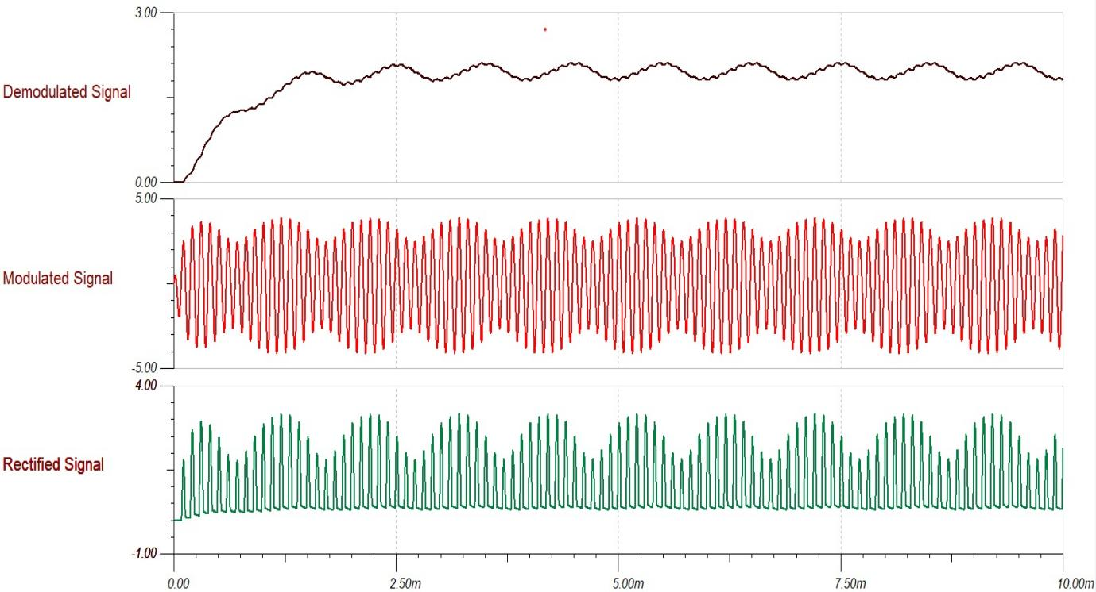
Figure 4.5 Result of AM Demodulation

Interpretation of Results
4.3.1 Amplitude Modulation:
The amplitude of the carrier signal varies in accordance with the instantaneous amplitude of the modulating signal is called amplitude modulation. Which means, the amplitude of the carrier signal, which contains no information, varies as per the amplitude of the signal, at each instant, which contains information. The carrier amplitude varied linearly with the modulating signal, which usually consists of a range of audio frequencies. The frequency of the carrier is not affected.
Time-Domain Representation of the Waves:
Let the modulating signal be,
(𝑡) = 𝐴mcos(2π𝑓𝑚𝑡) …………. (4.14)
and the carrier signal is,
(𝑡) = 𝐴𝑐cos(2𝜋𝑓c𝑡) …………... (4.15)
Where ,
- Am and Ac are the amplitudes of the modulating signal and the carrier signal respectively.
- fm and fc are the frequency of the modulating signal and the carrier signal respectively.
Then the equation of AM signal wave will be,
𝑆$A_{m}$ (𝑡) = 𝐴𝑐 [1 + 𝐾𝑎𝑚 (𝑡)] cos(2𝜋𝑓𝑐(𝑡)) …………. (4.16)
- Where ka is called as amplitude sensitivity.

4.3.2 Modulation Index:

The Carrier wave, after being modulated, if the modulated level is calculated, then it is called as modulation index/ modulation depth.
It states that the level of modulation that a carrier wave under goes
$SA_{m}\left(t\right)=A_{C}\left[1+KaA_{m}\cos\left(2πfmt\right)\right]\cos\left(2πfc\left(t\right)\right)$ ……….. (4.17)
$$=A_{C}\left[1+μ\cos\left(2πfmt\right)\right]cos⁡(2πct)$$
$$μ=A_{m}/A_{c}$$
Where, μ is modulation index and it is equal to the ratio of Am and Ac
$$μ=A_{m}/A_{c}$$

Let Amax and Amin be the maximum and minimum amplitudes of the modulated wave.
We will get the maximum amplitude of the modulated wave,
Where, cos(2𝜋𝑓m𝑡) is 1.
$A_{max}= A_{c}+A_{m}$ ……….. (4.18)
We will get the minimum amplitude of the modulated wave,
Where, cos(2𝜋𝑓m𝑡) is -1.
$A_{min}=A_{c}+A_{m}$ ………… (4.19)
Adding both the equations
$A_{max}+A_{min}=A_{m}+A_{c}−A_{m}$………… (4.20)

$A_{c}=(A_{max}+A_{min})/2$ ………… (4.21)

Subtracting both the equations
$A_{max}−A_{min}=A_{c}+A_{m}−(A_{c}−A_{m})$ ………… (4.22)

$A_{m}=(A_{max}−A_{min})/2$ ………… (4.23)

$\frac{A_{m}}{A_{c}}=\frac{A_{max}−A_{min}}{A_{max}+A_{min}}=μ$ ………… (4.24)

- The modulation index or modulation depth is often denoted in percentage, called the Percentage of Modulation. We will get the percentage of modulation by multiplying the modulation index value by 100.
Modulation Percentage = $\frac{μ}{100}$

4.3.3 Amplitude Demodulation (Detection by using Envelope detector:

The process of detection provides a means of recovering the modulating Signal from modulating signal. Demodulation is the reverse process of modulation. The detector circuit is employed to separate the carrier wave and eliminate the side bands.
Since the envelope of an AM wave has the same shape as the message, independent of the carrier frequency and phase, demodulation can be accomplished by extracting envelope. An increased time constant RC results in a marginal output follows the modulation envelope. A further increase in time constant the discharge curve become horizontal if the rate of modulation envelope during negative half cycle of the modulation voltage is faster than the rate of voltage RC combination, the output fails to follow the modulation resulting distorted output which will occur even at high modulation index. With diode D1 and the resistors, we half wave rectify the signal. Then with the filter capacitor we try to follow the envelope of the signal. The crucial point when designing this circuit is that we have to choose RC time constant so that, it is not too small to avoid excessive discharges between peaks, and we don't have to choose it too large, to make it possible for the capacitor to follow the signal.
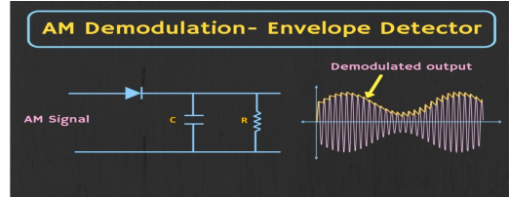

Chapter 05: Conclusion and Future Scope

Conclusion
This project successfully demonstrates the working of an Amplitude Modulator and Demodulator system and provides a clear understanding of the fundamental principles of analog communication. The main objective of transmitting a low-frequency message signal by modulating it onto a high-frequency carrier and recovering the original signal at the receiver end has been achieved effectively. The modulator circuit generated a proper amplitude-modulated waveform in which the carrier envelope accurately followed the message signal, while the demodulator circuit successfully extracted the original information using envelope detection. The experimental and simulation results closely matched the theoretical concepts, validating the effectiveness of the designed system.
Through the successful implementation of this project, important concepts such as modulation, demodulation, modulation index, bandwidth, noise effects, and signal recovery were thoroughly understood. The project enhanced practical knowledge of electronic components and communication circuits, bridging the gap between theory and real-world implementation. Although amplitude modulation has certain limitations, its simplicity and foundational importance make it a valuable learning tool. Overall, this project serves as a strong base for understanding more advanced analog and digital communication techniques.

Limitations

Limitations of AM Modulator (Transmitter):
- Low Power Efficiency:
In amplitude modulation, most of the transmitted power is concentrated in the carrier, while only a small portion is used for transmitting the actual information in the sidebands. This results in inefficient power utilization and reduced transmission range.
  - Bandwidth Inefficiency:
AM requires a bandwidth equal to twice the highest frequency of the message signal. This leads to wastage of spectrum when compared to more efficient modulation techniques.
- Susceptibility to Noise:
Since information is carried in the amplitude of the signal, any noise or interference directly affects the signal amplitude, causing distortion at the receiver.
- Over-Modulation Problem:
If the modulation index exceeds unity, over-modulation occurs, resulting in envelope distortion and loss of information.

Limitations of AM Demodulator (Receiver):
- High Noise Susceptibility:
AM demodulators are highly sensitive to noise because noise directly alters the amplitude of the received signal, leading to poor signal recovery.
- Poor Audio Quality:
Due to limited bandwidth and noise effects, the recovered audio signal lacks high-frequency components, resulting in reduced sound quality.
- Dependence on Proper Envelope:
Envelope detectors require a properly modulated signal. Any distortion in the envelope causes incorrect demodulation.
- Limited Performance in Weak Signals:
At low signal strengths, envelope detection becomes unreliable, leading to increased distortion and loss of clarity.

5.3 Further Enhancement and Future Scope
The future scope and enhancement of amplitude modulation (AM) and demodulation lie mainly in their adaptation and integration with modern communication technologies. Although AM is no longer widely used in its traditional analog form, its fundamental concepts continue to play an important role in advanced communication systems. Improved and more efficient modulation techniques such as Single Sideband (SSB) and Quadrature Amplitude Modulation (QAM) have evolved from basic AM principles, offering better noise immunity and higher spectral efficiency.
With the growing demand for reliable and high-quality communication, modern digital modulation schemes have largely replaced conventional AM due to their superior resistance to noise and efficient use of bandwidth. However, AM remains a foundational technique for understanding complex modulation methods and serves as a stepping stone toward advanced analog and digital communication systems. Thus, the study of AM and demodulation continues to be relevant for educational purposes and for exploring future developments in communication enginee

References

[1]. Hubert Ward, “Mastering Analog Electronics: Unlocking the power of circuits and semiconductors”, Published by Apress on August 20, 2024 in Berkely, CA, USA.
[2]. Robert L. Boylestad and Louis Nashelsky, "Electronic Devices and Circuit Theory, Pearson Publication House, 2015.

Appendix 01

A01.1. Data Sheet I

List of Major Components Used
SL No. | Component Name | Specification / Model | Purpose in Circuit
1 | Bipolar Junction Transistor | BC107 (NPN) | Acts as an amplitude modulator by varying the collector current in accordance with the modulating signal applied at the base.
2 | Operational Amplifier | µA741 | Used as a buffer amplifier in the demodulator stage to provide high input impedance and low output impedance without signal distortion.
3 | Zener Diode | BA792 (5.1 V) | Maintains a constant reference voltage and protects the circuit from voltage fluctuations and overvoltage conditions.
4 | Diode | General Purpose Diode | Performs envelope detection by rectifying the modulated carrier signal to recover the original message signal.
5 | Resistors | Fixed value resistors | Provide proper biasing to active components and limit current to ensure safe and stable circuit operation.
6 | Capacitors | Electrolytic / Ceramic | Used for signal coupling, DC blocking, noise reduction, and filtering of unwanted frequency components.
7 | Inductor | RF Choke / Tuned Inductor | Used in tuning and filtering by allowing DC and low-frequency signals while opposing high-frequency carrier components.

A01.2. Data Sheet II

Transistor Data Sheet Summary
S. No. | Parameter | Specification
1 | Transistor Name | BC792
2 | Transistor Type | PNP
3 | Maximum Collector Current (Ic max) | −100 mA
4 | Maximum Collector–Emitter Voltage (Vce max) | −45 V
5 | Maximum Emitter–Base Voltage (Veb max) | −6 V
6 | Power Dissipation (Pd) | 300 Mw
7 | DC Current Gain (hFE) | 110 – 800
8 | Operating Temperature Range | −55°C to +150°C
9 | Package Type | TO-92
10 | Application | Low-power signal amplification and switching

Operational Amplifier Data Sheet Summary
S. No. | Parameter | Specification
1 | IC Type | Operational Amplifier
2 | Supply Voltage Range | ±12 V to ±15 V
3 | Open Loop Gain | Very High
4 | Input Impedance | Very High
5 | Output Impedance | Low
6 | Bandwidth | Wide
7 | Slew Rate | Moderate
8 | Input Offset Voltage | Low
9 | Power Supply Rejection Ratio (PSRR) | High
10 | Application | Signal buffering and amplification

